**Institute of Engineering & Management**

**Department of Computer Science & Engineering**

**Object Oriented Programming (IT) Lab for 3rd year 5th semester 2018**

**Code: CS594D**

**Date:** 17/07/18

**WEEK-2**

**Assignment-1**

**Problem Statement:** Write a Java program for addition and multiplication of complex numbers

**Source Code:** import java.util.Scanner;  
  
class cCal  
{  
 public static void main(String args[])  
 {  
 int n1,n2;  
 Scanner sc = new Scanner(System.in);  
 System.out.println("Enter the 1st complex number");  
 n1 = sc.nextInt(); n2 = sc.nextInt();  
 complex c1 = new complex(n1, n2);  
 System.out.println("Enter the 2nd complex number");  
 n1 = sc.nextInt(); n2 = sc.nextInt();  
 complex c2 = new complex(n1, n2);  
 System.out.print("Section which operation:\n 1: Addition\n 2: Multiplication\nEnter: ");  
 n1 = sc.nextInt();  
 sc.close();  
 if(n1 == 1)  
 c1.add(c2);  
 else c1.mult(c2);  
 if(c1.imag >= 0)  
 System.out.println("The resultant complex number: "+c1.real+" + "+c1.imag+"i");  
 else System.out.println("The resultant complex number: "+c1.real+" - "+(-c1.imag)+"i");  
 }  
}  
  
class complex  
{  
 int real, imag;  
 complex(int n1, int n2)  
 {  
 real = n1;  
 imag = n2;  
 }  
 void add(complex c)  
 {  
 real += c.real;  
 imag += c.imag;  
 }  
 void mult(complex c)  
 {  
 int temp = real;  
 real = real*c.real - imag*c.imag;  
 imag = temp*c.imag + imag*c.real;  
 }  
}

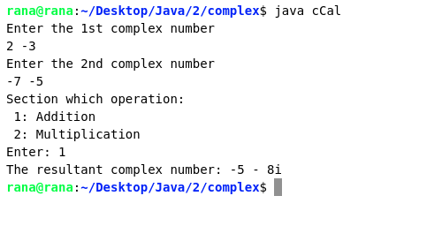**Screen-Shots:**

**Fig:** Addition

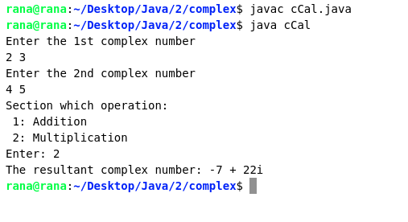

**Fig:** Multiplication

**Assignment-2**

**Problem Statement:** Write a Java program to implement a stack.

**Source code:**   
import java.util.Scanner;  
  
class StkImp  
{  
 public static void main(String[] args)  
 {  
 int n=0;  
 Scanner sc = new Scanner(System.in);  
 Stack st = new Stack();  
 System.out.println(" ---- Stack ----\n");  
 System.out.print("Enter the following commands:\n 1:push\n 2:pop\n 3:display\n 4:exit\n");  
 do {  
 System.out.print("Enter command: ");  
 n = sc.nextInt();  
 switch(n)  
 {  
 case 1: System.out.print("Enter the element: ");  
 st.push(sc.nextInt()); break;  
 case 2: st.pop(); break;  
 case 3: st.display(); break;  
 case 4: System.out.println("Bye!"); break;  
 default:System.out.print("Again ");  
 }  
 }while(n!=4);  
 sc.close();  
 }  
}  
  
class Stack  
{  
 int top = -1;  
 int[] arr = new int[100];  
 void push(int n)  
 {  
 if(top<100)  
 arr[++top] = n;  
 else System.out.println("Stack overflow");  
 }  
 void pop()  
 {  
 if(top>-1)  
 top--;  
 else System.out.println("Stack underflow");  
 }  
 void display()  
 {  
 if(top == -1)  
 System.out.println("No elemnets to print");  
 else  
 {  
 System.out.print("The elements are: ");  
 for(int i=0; i<=top; i++)  
 {  
 System.out.print(arr[i]+", ");  
 }  
 System.out.println();  
 }  
 }  
}

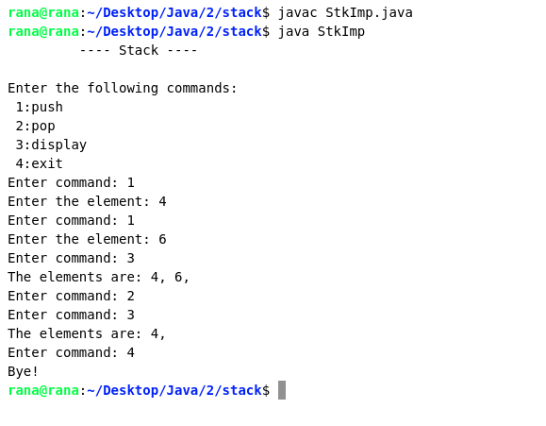**Screen-Shot:**

**Fig:** sample I/O (1)

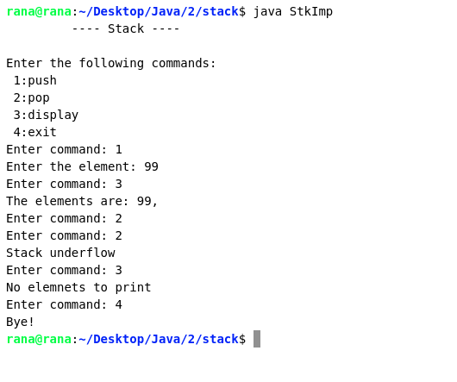

**Fig:** sample I/O (2)